KGS SWE Intern

input(): It is a pre – defined functions that helps to get a customized value from the user during the execution time in string format
print(): It is a pre – defined functions that helps to display the o/p on the screen
Eg: input(“Enter a value: “)
Operators:
Eg: 7 + 34
Operands: 7,34
Operator: +
Operation: Addition
Operands: the values that are involved in an operation
Operator : a special symbol or keyword that includes in-built functionality based on which the operation is performed on values
Operation: It is an action that is performed on values based on the operator used
There are totally 7 types:
- Arithmetic op
- Comparison / Relational op
- Logical op
- Bitwise op
- Assignment op
- Membership op
- Identity op
Arithmetic op:
- To perform mathematical operations on numbers
- i/p numbers
- +, - ,* ,**, // , /

+:
- When used with minimum of 2 numbers
- When used with single number it represents +ve sign
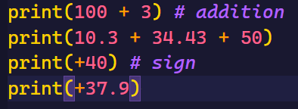

- * : compulsorily when used with minimum of 2 numbers it performs multiplication
- ** : It returns the exponent value of the given base and power also works with decimals
Base ** Power 2^3 2 – base , 3 – power
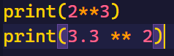

Division op
// floor div returns non decimal
/ float div returns decimal
% modulus returns remainder
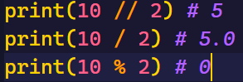

2. Comparison / Relational op:
- It is used to compare minimum of 2 values
- It returns Boolean value (True or False)
- Any values can be taken as i/p
<,>,==,!=,<=,>=
True,False,None special kind of keywords that holds values
True -> 1
False -> 0
None -> Nothing 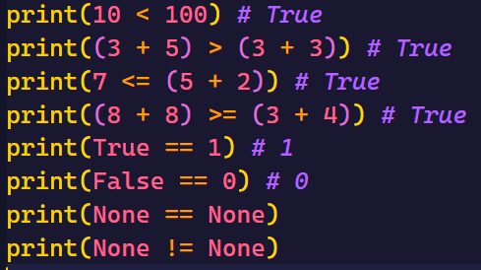
3. Logical op:
- It is used to combine and check multiple boolean conditions
- i/p bool condition
- o/p Boolean value or anything that represents bool value
- types: and, or, not
Bool cond:
- Direct bool_val or anything that represents bool val
- An expression that returns bool_val or anything that represents bool val
- Any var that hold bool val or anything that represents bool val
AfterNoon
Conditional Statements
If , elif , else , nested if
Note: any non zero value is True it can be negative also 10, -10
“”, 0, False, None, [ ], { }, ( ) Empty Object is considered False

Not:
- It accepts only one single operand to perform the operation
4. Bitwise op:
Types:
- Bitwise and &
- Bitwise or - |
- Bitwise xor - ^
- Bitwise not / negation / compliment - ~
- Bitwise left shift - <<
- Bitwise right shift - >>
- Bitwise unsigned left shift - <<<

Assignment Op: [=]
- Commonly it doesn’t return any val
- It stores / copies the val mentioned on RHS to the named memory location on the LHS
Syn:
Var_name1 = val [initialization]
Var_name2 = var_name1 [copying]
Var_name2 = val [re-initialization]
Variables:
- It is a named memory location that holds single valued data
- It is a name that is given to a container that holds data
- If we try to store the same val into different variables, then internally all the variables will be pointing to the same shared memory location
[Note: id() it si a pre- defined function that displays the ID value of the provided data
ID It is an interger value that is generated by the PVM during execution time based on the value stored or memory allocated]
- If multiple val’s are tried to be stored into the same var at the same time then, PVM will convert it into a TUPLE data structure and it’s object address will be stored into the variable
- If multiple val’s are being tried to be stored into the same variable one after the other then internally different memories will get allocated for each initialization
- It is compulsory to initialize a variable before utilization

Varieties of Variables: [Compound Stmts]
Arithmetic + Assignment: +=,-=,*=,**=,//=,/=,%=
Bitwise + Assignment : &=,|=,^=,<<=,>>=,<<<=

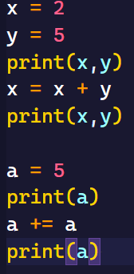
Rules:
- Whenever the operand used on RHS for operation and LHS for updation is the same
- It is compulsory to use initialized var’s
- Apart from the initialized var’s even direct constants can be used
- Minimal of 2 operands are required to perform the operation
- The operand which is used on RHS for operation and LHS for updation, should be present on the LHS of the operation
Eg: a= a + b Valid
a= b + a Invalid
Note: ~= is not included under compound stmts as it requires only a single operand to perform the operation
Identity op: [is , is not]
- It compares the ID’s of the given 2 val’s
- It returns only Boolean value
Membership Op: [in, not in]
- It checks whether the specified ele is available in a group of ele’s or iterable object or not
- It returns only Boolean Val
Iterable Obj: Objects that can hold multiple
Control Flow stmts:
The stmts that controls the execution flow of the prog
Types:
- Conditional stmts
  - Simple if
  - If – else
  - Elif ladder / if-else-if ladder
  - Shorthand if
- Lopping stmts
  - For loop
1 for with range()
- Incre
- Decre
2 for without range()
  - While loop
- Jumping stmts
  - break
  - continue
  - return
for loop:
- for with range():
range():
    - It is pre-defined function
Syn: range(start,stop/end,step)
    - Start, stop,step only be integers
Start From where the sequence should begin
Default start 0
End/ stop It is compulsory to be passed Defines till where the sequence should get executed
Step the difference between the current ele and the next ele default step +1
For with range():
For var_name in range(start,end,step)
#logic
#remaining stmts
- Incrementin for loop:
For var_name in range(start ,(actual end +1),positive_step):
#logic #remaining stmts

Eg : program to print natural numbers from the beginning with a difference of 3 upto n(included)

Rules:
    - Pass a positive step
    - Start < mentioned_end
    - If the actual end val also need to be included then: (actual_end + 1)
- Decrementing for loop:
For var_name in range(start,(actual end - 1),negative_step):
#logic
#remaining stmts

Eg: program to display the natural numbs starting from n to 1 in a decrementing order with a diff of 4

Rules: - compulsorily pass a -ve step
    - Start > mentioned_end
    - If the actual end val also need to be included then:
    - (actual_end - 1)
- For without range():
for var_name in iterable_obj / group_of_ele’s:
#logic
Remaining stmts
Rules:
- No single valued data
- The cursor moves only in forward direction
- It directly fetches each individual val
- Even empty iterable objects work
- Group of ele’s can be passed by segregating them using “,”
Note:
For with range when used on iterable object like arrays / strings , it represents the index
For without range when used on iterable object like arrays / strings , it represents the val’s

Wap display whole number stating from n in a decrementing order with an incrementing diff
Can range be used with while yes but it has no use because we have to initialize and increment
Jumping Stmts:
1. Break: It is a keyword that helps to exit the current loop in which it is present
2. continue: It is a keyword that helps to skip the current cycle logic and updates to the next cycle
Eg: WAP to display the number entered by the user until he enters 0, Once 0 has been entered then terminate the reptation and suppose if the user enters 10 or 100 just skip the logic and continue with the loop
Expected o/p:
Enter num: 1
Entered num is: 1
Enter num: 2
Entered num is: 2
Enter num: 3
Entered num is: 3
Enter num: 10
Enter num: 100
Enter num: 0
Prog Exec !!
Functions :
- Independent block of code included to perform a specific action based on the inputs provided
- A function can execute it’s logic only when it is being called
Syn:
#fucnction declaration
Def function_name(parameters):
# function definition/ body of a function / scope of a function
# logic
Return val / val’s
# function call
Var_name = function_name(arguments)

BookingTicket()
Parameters: the i/p that is required by a function to execute a logic
Argument: the val’s that are passed to a function during a function call, for it to execute the logic
Return:
    - It’s a keyword
    - It’s the last executable line of code within a function, once “return” works no other line of code within the function will execute
    - Uses:
      - It instructs the PVM to take back the execution flow from called function back to the function call
      - It helps to return val or val’s from called function back to the function call
2] Wap to check whether the given year is leap year or not using func
Find out major logic and cut it to function block and return and call it in main
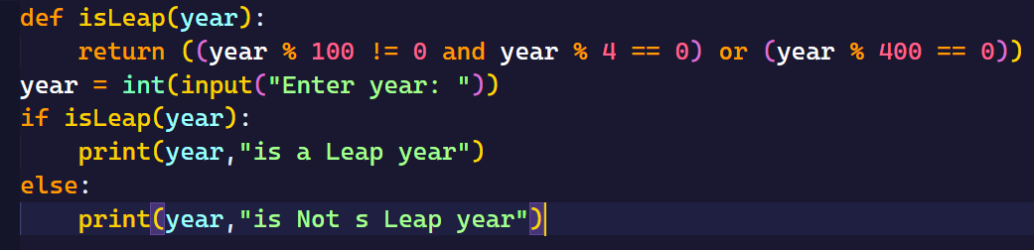
3] WAP a program to display all the leap year present in a user defined range
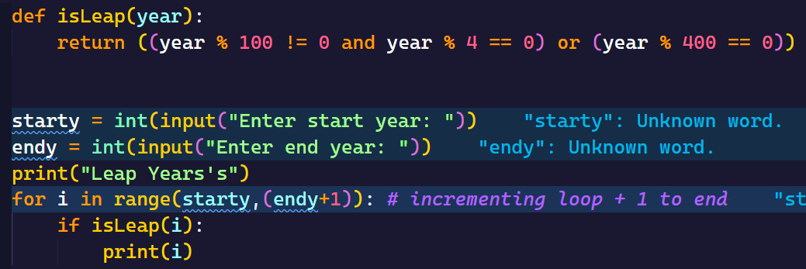
4] WAP to display all the Leap Years and non leap years present in a user defined range separately
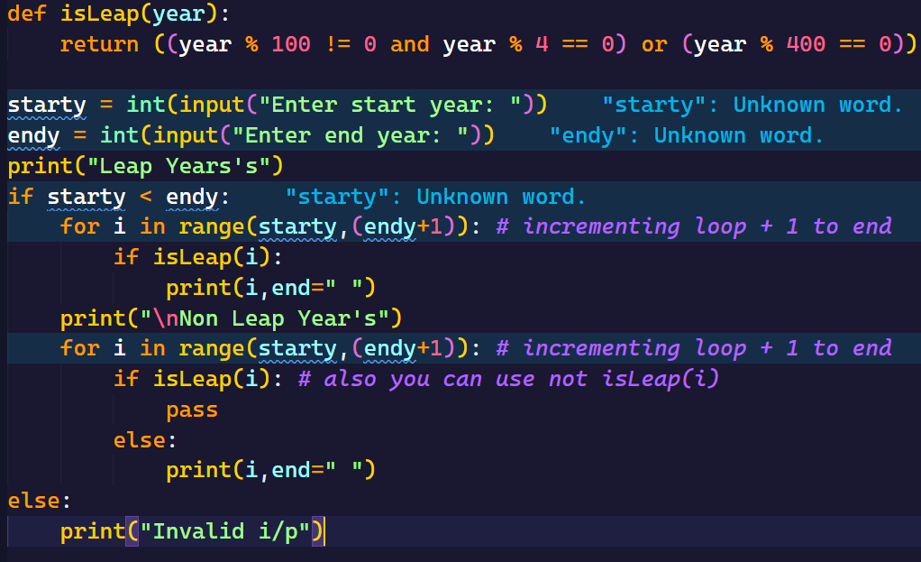
Count Digits:
WAP to count the number of digits present in a given number.
1 <= n <= 10 ** 5
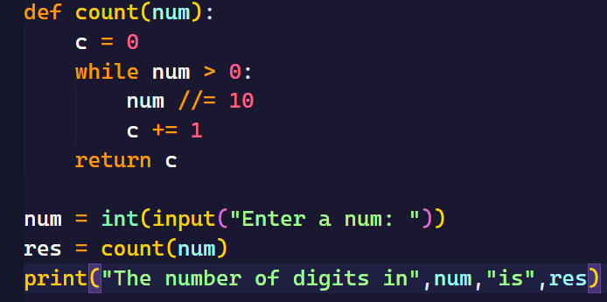
WAP to check if a given number is amstrong number or not
ASN (ARM Strong Number):
- If the sum of the exponent val(base each digit, pow tot count of digits in a given number) of all the digits individually in a given number is same as the original number.
Eg: 153 get digits pow (3) 3 ** 3 + 5 ** 3 + 1 ** 3 check with num == asn T
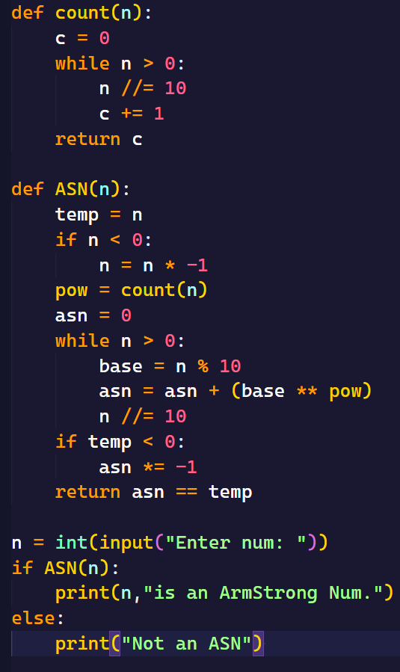
2] WAP to display all the ASN present in a user defined range
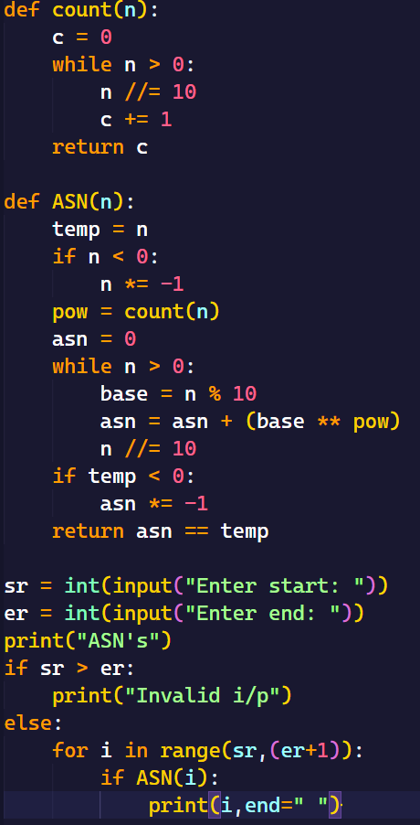
3] WAP to display all the ASN and no ASN in a user defined range separately.
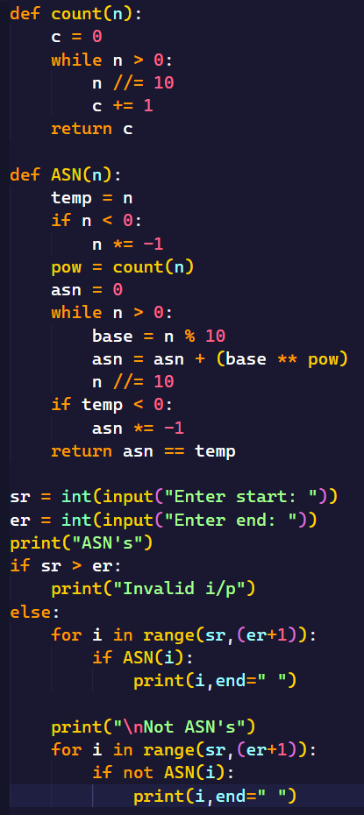
4] WAP to display first n ASN.
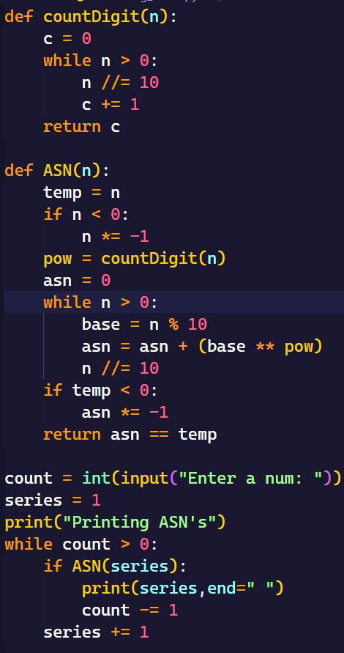
5] WAP to display first “n” non ASN’s
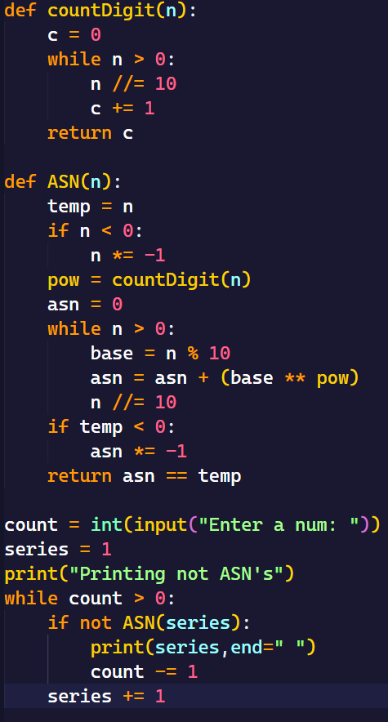
6] WAP to display the first n ASN and non ASN’s separately.
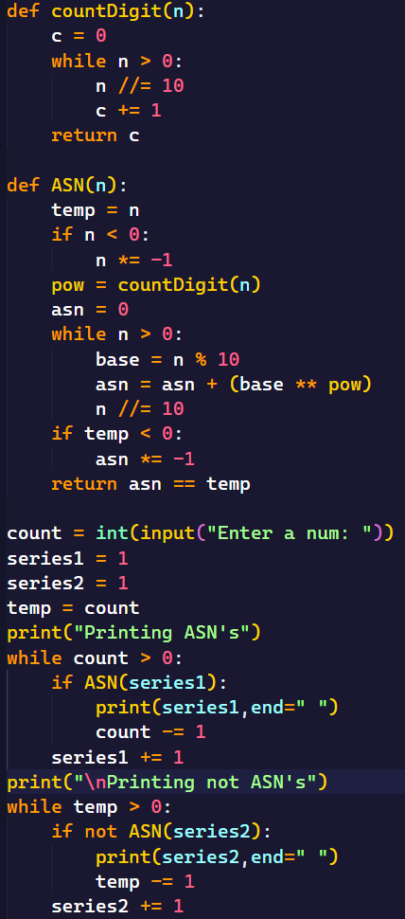
7] WAP to reverse all the numbers present in a user defined range.
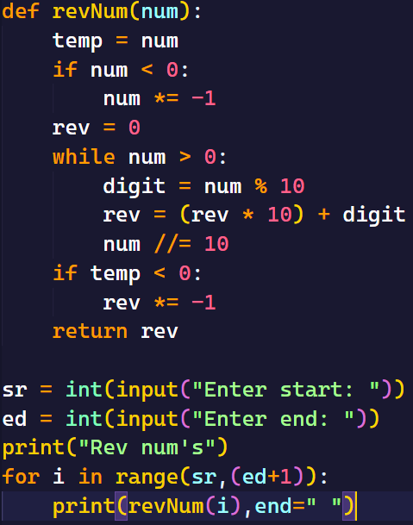

8] WAP to reverse all the numbers present in a user defined range in decrementing order
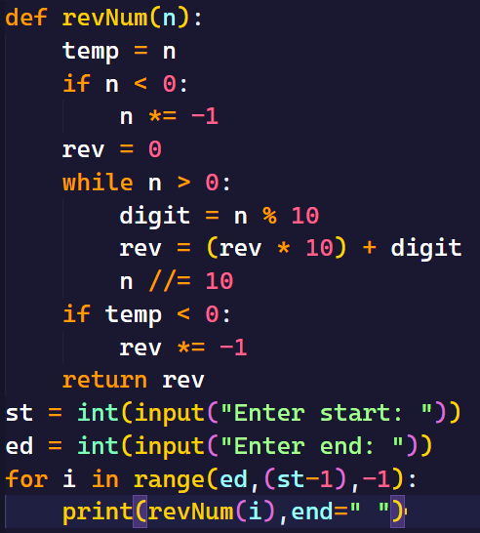
9] WAP to reverse only the odd numbers present in a user defined range.
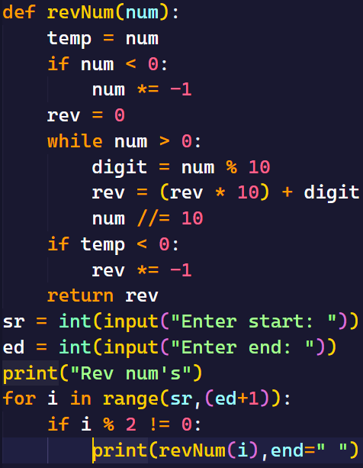
10] WAP to reverse all the numbers present in a user defined range and display the even and odd numbers separately
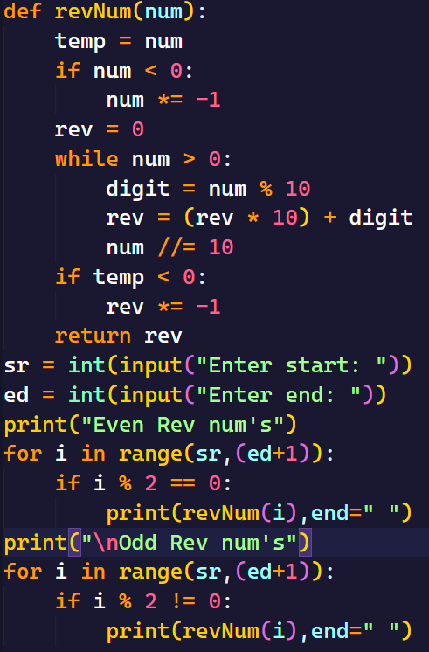
Interger Palindrome: A number said to be an integer palindrome only when the reversal of an number is same as the original number
Eg: 101 101 == T
-29 -92 == F
1] WAP to check whether the given number is an Integer Palindrome or not.
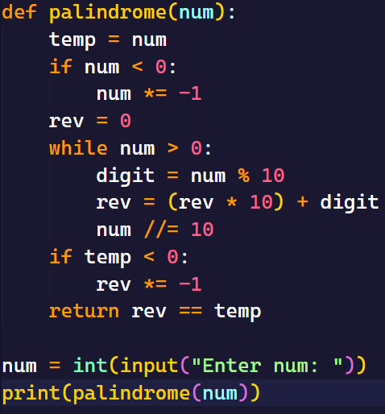
2] WAP to display all the Integer Palindrome’s present in a user defined range.
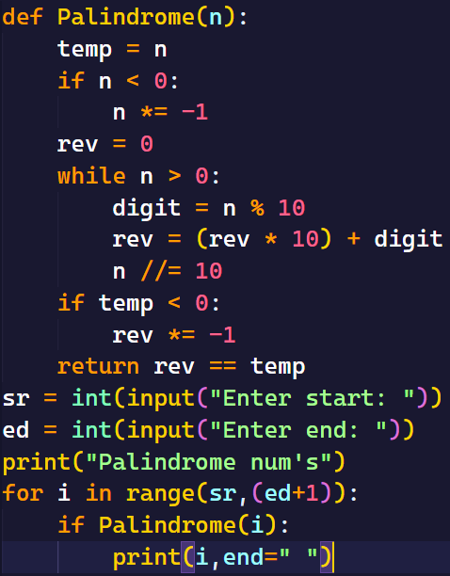
3] WAP to display all the Non Integer Plaindrome present in a user defined range
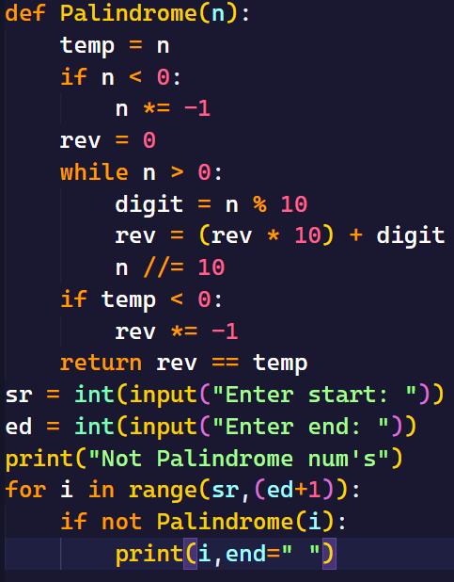
4] WAP to display all the Integer palindrome and non integer plaindrome’s present in a user defined range separately
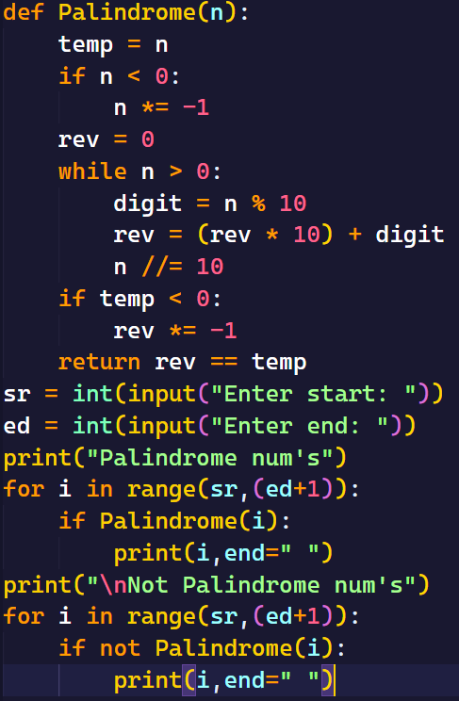
5] WAP to display the first “n” Interger Palindrome’s

6] WAP to display the first “n” Non Interger Palindrome’s
Factors: An Element is said to be the factor of a number when the element is able to divide and reduce the number down to zero.
All the factors of a given num will lie within the range of 1 to num itself
The least factor of a num is 1 , highest factor of a num is num itself
1] WAP to display all the factors of the number
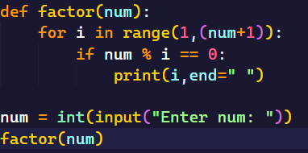
Logic 2 for Factors:
All the Factors of the given number can be displayed within the range of 1 to direct square root of the given number or lower nearest square root of the given number
2] WAP to display all the factors of the number Logic 2
3] WAP to display all the factors of each an every number in user defined range
4] WAP to display all the factors of first “n” numbers
5] WAP to display all the factors of first “n” odd numbers
Prime Numbers:
- The numbers which have exactly 2 factors i.e 1 and the number itself.
- There are no negative prime numbers
1] WAP to check whether the given number is prime or not
2] WAP to display all the prime numbers present in a user defined range
3] WAP to display all the non prime numbers present in a use defined range in decrementing order
Eg: sr = 1 en = 10 – 10 9 8 6 4 1
4] WAP to display first “n” prime numbers
5] WAP to display first “n” non – prime numbers.
HCF / GCD :
- Highest common Factor / Greatest common Divisor
- For given 2 numbers which is the highest ele that can commonly divide and reduce the i/p num down to 0 that ele is said to be HCF

1] WAP to display HCF / GCD of the given 2 numbers
Co – Primes:
The 2 num’s are said to be Co-Primes to each other if and only if the HCF / GCD of the nums is exactly 1
1] WAP to check whether the given 2 num’s are co-primes or not
Methods : dependent
Class:

Recursion:
- It is the process of function calling itself for certain number of times
Syn: 1. Where there is no return value
# called function
def func_name(parameters):
# base cond
# logic
# recursive func call
Func_name(arguments)
# initial function call
Func_name(arguments)
Syn: 2. Where there is return value
# called function
def func_name(parameters):
# base cond
# logic
# recursive func call
return Func_name(arguments)
# initial function call
Var_name = Func_name(arguments )
Base cond The condition which controls the recursive function call
It is decided based on when should the recursive call stop
RecursionError It is thrown by the PVM when memory resource is asked beyond the avialablity
It is generally led:
- When there is unlimited recursive call
- When the i/p num is very huge
Initial function call It is the first call of a function, without it no function will be executed
It generally would be outside the recursive function which it is calling
In recursion the arguments passed should be the first value for the parameters
Recursive function call It is the call that is made to repeat the logic
It is placed within which the function need to be repeated
In recursion, the arguments passed should be the
- the updated val that need to be carry forwarded to the next cycle for further operations
- the val which may not be updated but is required by the next cycle
1] WAP to display numbers from 1 to n in incremental order
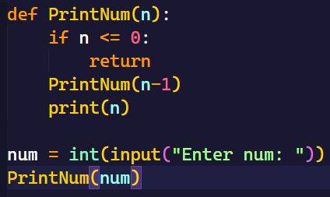
2] WAP to display the below series by getting user defined n.
N = 4 4 3 2 1 1 2 3 4
    - No change in base cond
    - No change in recursive func call
    - No 3rd var allowed
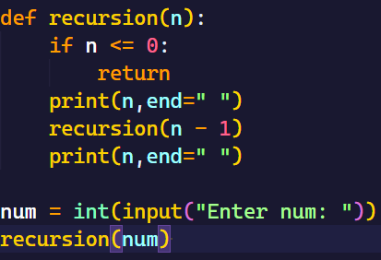
3] WAP to display the below series by getting user defined n.
N = 4 1 2 3 4 4 3 2 1
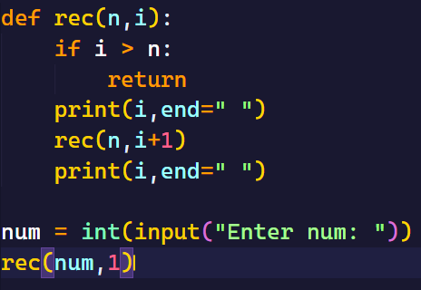

4] WAP to reverse an Integer(+ve) Number using recursion.
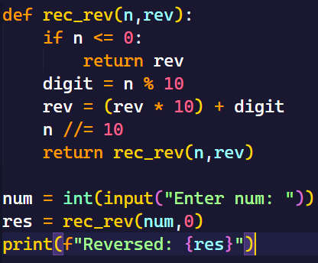
5] WAP to count digits using recursion
6] WAP to display the Fibonacci series for the given position
Patterns:
- Combination of rows and columns
- Rows sleeping line/horizontal lines -------------
- Coloums standing lines/vertical lines |

- To keep the patterns dynamic,make the count of num of rows as customized

4<=n<=15
- Once the cursor moves to the next line, it cannot be brought back to the previous line
- Cursor moves from top to bottom and left to right approach
- Varieties of patterns: Star,Number,Alphabetic
- Types : Non – Combinational Patterns: Triangles,square,parallelogram
Combinational Patterns: K-Pattern,Triangle,Diamond,Butterfly
- Print(): To move the cursor control to the beginning of the next line
If any val has been passed then display it and move the cursor control to the beginning of the next line
1] i loop is always dependent on n value
2] j loop should be dependent on n or i or any other variable

Alphabetic Patterns:
- Each and every character is internally represented as integers. These integer representation is called as “ASCII” values (American Standard Code for Information Interchange)
- The extended version of ASCII val UNICODE val’s
- ASCII val’s have 256 characters, ranging from 0 to 255 characters
- ‘ ’(space) 32
- ‘0’ to ‘9’ 48 to 57
- ‘A’ to ‘Z’ 65 to 90
- ‘a’ to ‘z’ 97 to 122
Ordinal function: ord()
It returns the interger representation of the provided single character
Syn: ord(single_character)
Character function: chr()
It returns the character representation of the provided whole number
Syn: chr(Whole number)
Logic: Uppercase chr(64 + val)
Lowercase chr(96+val)

Hollow Patterns:

